ASCtoFMConverter User Guide

Altered States of Consciousness (ASC) data is collected in a continuous fashion with “trial” lengths often measured in minutes. In order to extract features of the physiology from these states, it is necessary to split the continuous data into workable record lengths for processing by FILMAN (FM). In the following, the term episode is intended to generally indicate one of these “trial” segments. ASCtoFMConverter can be used to describe these episodes and the processing needed to create a FM file by “chopping” the episodes into shorter records.

On starting the program, one is presented with the following dialog box for opening the header (HDR) file of the dataset to be processed.

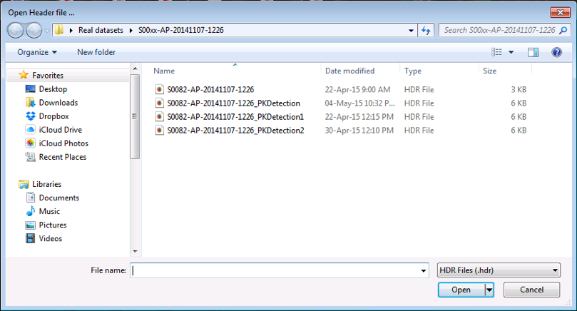

After the dataset is opened one is presented with this window which one uses to describe the processing to be performed. This window is divided into regions for describing the episodes, naming the group variables (GV) to be included in the FM file, the channels to be included, how the samples are to be processed, and the referencing to be used on the samples.

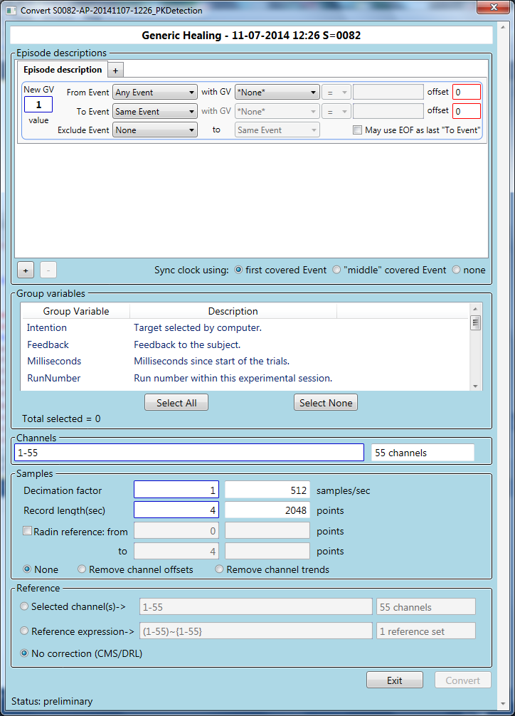Episode descriptions is the most complicated of these segments. Multiple descriptions may be used for a given FM file and each may be labeled by a GV value, entered on the left of each description panel. This GV is named “NewGroupVariable” in the FM file created. Each episode type is described by a panel:

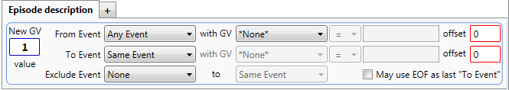

To describe an episode one must indicate an Event at the beginning of each episode (“From Event”) and an Event at the end of the episode (“To Event”).

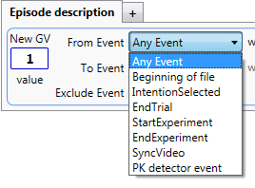In the drop-down are listed all the Events in the underlying dataset and two “anonymous” Events: Any Event and Beginning of file. These are generally self-descriptive.

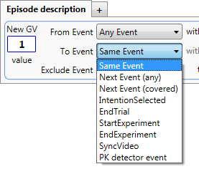A similar list is presented for the “To Event” row. Again, all the available GVs from the input dataset are included as well as some “anonymous” Events. Same Event is the same Event that started the episode. Next Event is the next chronological Event in the Event file, qualified by any to mean both covered and naked Events, and covered, only covered Events. Recall that “covered” implies that there is a corresponding change in the Status channel to the value of the Grey-code which identifies the Event in the Event file. This implies that “naked” Events have no such marker in the Status channel and that the timing of these Events is wholly dependent on the time recorded in the Event file record. This will be discussed further below when reviewing “clock synchronization”.

The Events selected for the beginning and end markers may be further refined by adding a GV criterion. Thus, for instance, in the example below, the beginning of these episodes would be marked by an “IntentionSelected” Event with the GV “Feedback” set to “NEUTRAL”. “IntentionSelected” Events with other values for “Feedback” would be ignored and not used to start data collection episodes.

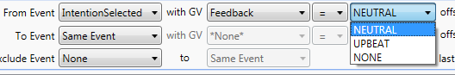

So let’s look at some examples of episode descriptions. In the first, “IntentionSelected” with a “Feedback” GV set to “NEUTRAL” would be sought to begin an episode, ending at the same Event, 24 seconds later, independent of any intervening Events. Note that “offset” refers to the



number of seconds displaced from the nominal Event that the actual data collection begins or ends. This value is positive for later or delayed, or negative for earlier or anticipatory timing.



Here we’ve used the same initiating Event, but the end of the episode is 4 seconds before the next “EndTrial” Event. If each “IntentionSelected” Event is paired with an “EndTrial” Event , this will work as (likely) intended. Of course, the trials need to be at least 4 seconds long; otherwise the episode will be skipped. Note that this means the offset is applied after the two Events are selected.



Here’s an example which might be used to collect baseline data. 60 seconds of data would be collected from the beginning of the BDF file. Note the *per force*, only a single episode of data is collected when using a “Beginning” of file “pseudo-Event”.



If a “StartExperiment” Event is available, one could use this example to collect data from the beginning of the file to 15 seconds before “StartExperiment”.

In this final example (below), we have used a simple “IntentionSelected” to “EndTrial” episode description, but used the “Exclude Event” feature to indicate that segments of data between Event “\*\*ArtifactBegin” and “\*\*ArtifactEnd” should be excluded from data collection. If any portion of a collected record includes data from the excluded segment, the record will no be created.

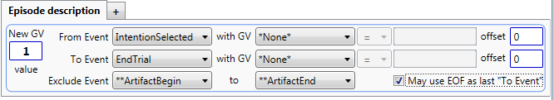

In addition, note that the “May use EOF as last ‘To Event’” checkbox has been marked. This means that if there is no terminating “EndTrial” Event after the last “IntentionSelected” Event, the end of file may be used as the terminating (pseudo-) Event. This should be used with caution as it indicates that the last trial may not have ended appropriately.

One further feature of the Episode description block has to do with clock synchronization. Recall that there are two different clocks involved in data collection: one is the clock implied by the collected data (and Status channel) on the BioSemi machine and the second is the clock in the Presentation machine that is used to record times in the Event records in the Event file. The link between these two clocks is the Status channel, used by Presentation to mark the times of covered Events. In order to synchronize these clocks, the time recorded in an Event record needs to be correlated with its corresponding mark in the Status channel and used to establish a “beginning of file” time for the BDF data file. In theory, from that point on one can use the times in the Event records to find a corresponding point in the BDF file.

There are potentially two problems with this: the first is that there is an unknown latency between the time that Presentation obtains the time data placed in the Event record and the marking of the Status channel through setting of the DIO value; and the second is that we have really only “synchronized” the two clocks at the Event used for synchronization, and from that point before and after, the clocks may be running at different tempos and thus drift apart. The first of these can be minimized by careful program logic, but the second is more difficult to solve. We have noted significant drifts in the clock times. The clock on Presentation is software-based and may run slow if the CPU is under any computational pressure. There is supposed to be a clock correction routine in Presentation that synchronizes its clock to an external standard using the so-called Network Time Protocol (NTP). The so-called BioSemi clock is in fact a hardware clock associated with the data collection hardware itself, and is thus not subject to software load exigencies.

That being said, in the short-trial (single FM record per trial) scenario, where timing is particularly critical, we have established a so-called “extrinsic Event” concept where the true Event is marked a second time in the BDF record to indicate the time of the corresponding Event on the BDF clock-schedule. Clock synchronization is less critical in ASC experiments as millisecond timing is not really required, and thus, generally, using the covered Event synchronization is adequate.

Three (actually four) choices are available:

1. Synchronization to the first covered Event in the Event file;
2. Synchronization to an Event selected near the middle of the overall time of data collection (the so-called middle Event);
3. Use estimated synchronization only (none):
   1. Estimate the time between the beginning of BDF data collection and the first recorded Event in the Event file; or
   2. Use the times recorded in the Event file assumed to be actual times from the beginning of BDF data recording.

The advantage of option 1 is that a special Event might be created to provide synchronization, the creation of which might be carefully controlled. Option 2 has the advantage that it may minimize the offset caused by relative clock drift. Options 3 should be used only when no properly covered Events are available for synchronization. The three main options are indicated by this control.



Options 3a and 3b are selected in a special dialog box presented as the conversion actually begins.